

Official User Guide

Table of contents:

1. Controls
2. Game Modes and objectives

**Controls**

**Common/Shared controls**:

* W/A/S/D: Move Up/Left/Down/Right respective
* F: Interact with interact-able objects/items
  + Npc and doors in main hub
  + Some objects in some games (further details below)

**Specific-to-game controls**:

* **Maze Runner (Game 1)**:
  + Only uses basic control scheme
* **Puzzle Party (Game 2)**:
  + Q/E/R/T: Cast a colour (if player is in possession of said colour)
  + Spacebar: Combine 2 colours (if they can be combined)
* **MCQ Power (Game 3)**:
  + F: Pick up a new answer or answer the question
  + Q: Swap your answer with the nearest alternative if you have already picked up one
* **Stress (Game 4)**:
  + F: Pick up a card/Place a card on a space. Used to press the stress button to score. Used to press reset button which will reset the pattern to remember but will also remove 10 seconds from the timer.

Game modes and objectives

**Game 1 (Maze Runner)**

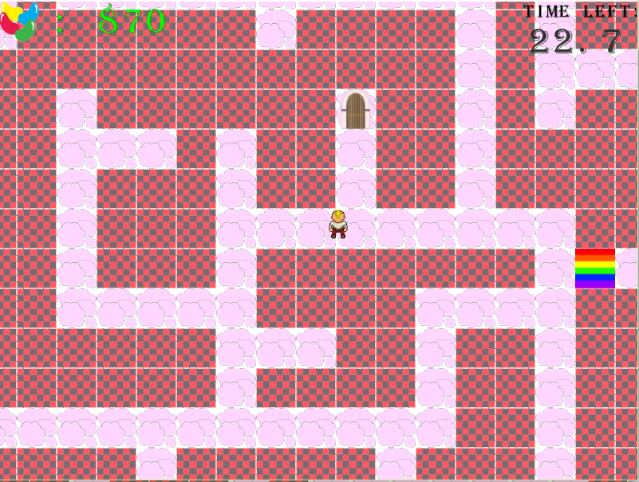

* **Description**:
  + This mini game is all about finding the exit inside the maze that the player is in. The spawning point and exit point is randomized so no two replays will be the same. There are also multiple AI’s set up to block your path.
* **Objective**:
  + Find the exit to the maze within the given time limit
* **Difference for each difficulty increase**:
  + Bigger levels
  + Random door spawn point (for medium and hard difficulty)
  + Random player spawn point
* **Hazards**:
  + AI’s (in the form of a rainbow) may block your path

**Game 2 (Puzzle Party)**

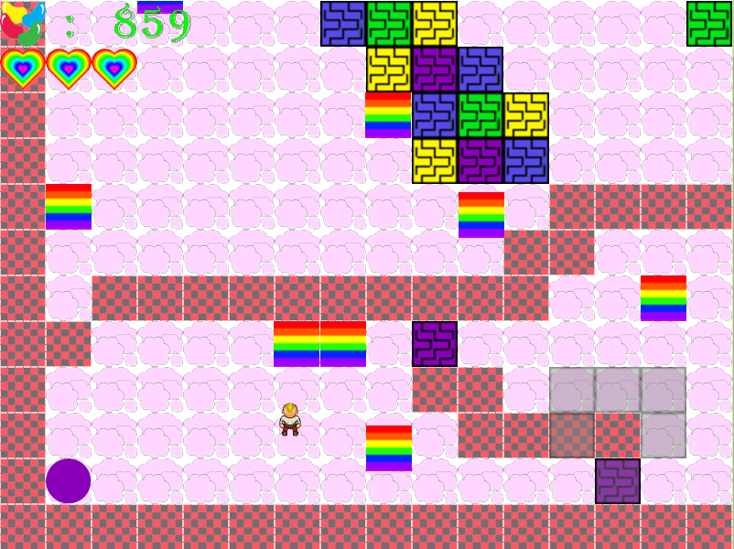

* **Description**:
  + This mini game requires the player to find different colours scattered across the stage and use them to destroy the coloured walls blocking his way by matching them together. He will have to avoid AI’s that will patrol the stage, or else, he will lose possession of the colours.
* **Objective**:
  + Get to the exit
* **Difference for each difficulty increase**:
  + More colours
  + More AI’s
  + More colour combinations
* **Hazards**:
  + AI’s (rainbows) will remove one colour that you have (random), if you have colours
  + If you don’t have colours, hitting an AI will reduce your lives by one

**Game 3(MCQ Power)**

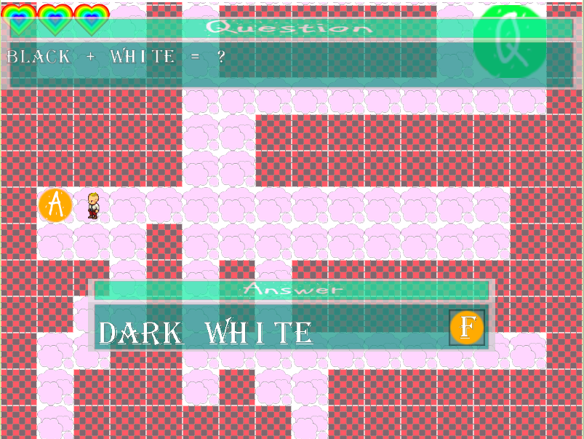

* **Description**:
  + This mini game requires the player to answer a set number of questions. Each question will have three different possible answers. Answering correctly will lead him to the next question, or the exit.
* **Objective**:
  + Answer all the questions to unlock the exit door
* **Difference for each difficulty increase**:
  + Harder questions
  + Bigger levels
* **Hazards**:
  + Answering wrongly will reduce your lives by one

**Game 4(Stress)**

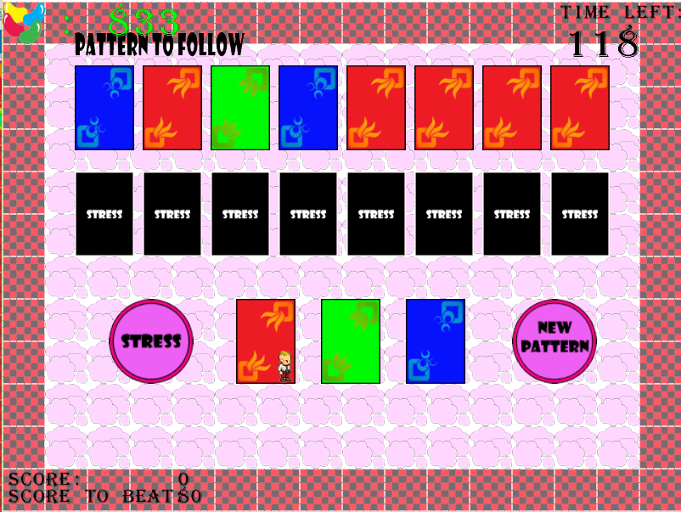

* **Description**:
  + This mini game requires the player to memorize a pattern of 3 different combinations of card colours. He will have to fill up the set with the 3 cards provided and push the “Stress” button to score. If his combination matches the randomized combination, he earns points. If not, nothing happens.
* **Objective**:
  + Score higher than the score to beat
* **Difference for each difficulty increase**:
  + Pattern to follow will be larger
  + Pattern will disappear faster
  + Score to beat will get higher
  + Timer will increase
* **Hazards**:
  + If you forget the pattern you will have to press the reset button which will remove 10 seconds from your timer